CS-000 Documentation Standards, Template & Revision Process
Doc ID | CS-000
Title | Documentation Standards, Template & Revision Process
Revision | D
Status | Draft, pending Lead signature
Effective date | 2026-10-10
Supersedes | Ad-hoc SN5 documentation practice

Approvals
Role | Name | Date
Author | Simon Starbuck (drafted with Claude, SN6 Resources) | 2026-07-12
Reviewer | simon (reviewer agent) | 2026-10-10
Approver (Composites Lead)

Revision history
Rev | Date | Author | Description of change
A | 2026-07-12 | Claude | Initial issue
B | 2026-07-28 | Claude | Language pass: fewer em dashes for rhythm variety, no content change.
C | 2026-08-28 | Claude | Engineering pass, requested by Simon Starbuck. §4 defines the normative verbs (shall/should/may) the whole series now reads by, and states that numbered procedure steps are requirements. §7.1 records where figures live and how they are rebuilt, because the series now carries drawn figures. New Figure 1, the status lifecycle.
D | 2026-10-10 | Claude (doc overhaul, requested by Simon Starbuck) | §5 names the markdown in src/ as the source, since the Google Docs are retired. §4 and new §7.5 define quick references. §7.2 gains steps for dependants, the rebuild and both deploys, with a new figure. §7.1 defines the lead's written signature and what an agent review covers. §2 says who owns values a lead changes in the app and that AI output is never a source. One letter per change set; a title is written once. "Monday meeting" becomes the weekly meeting (moved to Wednesdays). §8 checks run by script. §2 says the restock minimums are changed in the Firebase console, not in the app, and that a hold is edited from a step whose hold is running. The overhaul's Round 6 review fills every standard's Reviewer row with its date (R-000-20). Register R-000-01..16, R-000-18, R-000-19, R-000-20, R-IDX-04.

1. Purpose
We built good stuff in SN5 and barely wrote any of it down properly: not one doc had a revision number, changelog, or approver, and "what stack did the seat use last year?" was answerable only by whoever happened to remember (PP-09). This doc is how we name, structure, revise, and approve our documents so the knowledge outlives whoever wrote it. On a student team, turnover isn't a risk, it's a schedule.

2. Scope
All controlled composites documents: CS-XXX standards, work orders (WO-SNx-###), and formal deliverables (test reports, RCA docs). It does not control meeting notes, Slack threads, or scratch R&D notes, but any conclusion from those that the team relies on must graduate into a controlled doc.
Quick references (QR-XXX, §4) are covered here too, as derived documents without approval.
Some rules are enforced by the app from values a lead can change: the team cure holds (in the app, from the "Why N hours?" window of a step whose hold is running), the layup technique checklists (in the app, Reports → Layup techniques) and the restock minimums (in the Firebase console, config/restock; the app has no editor for them). Each has an owning standard: CS-008 for the holds, CS-013 for the techniques, CS-011 for the minimums. The owning standard states the rule and the value at its current revision and names the app as the live value. A lead who changes one of these values shall open a revision of the owning standard (§7.2) within two weeks.
Paul's answers, Steve's notes, and anything an AI read off a receipt, packing slip or label are not controlled documents and are never a source under §7.1 step 3. Cite the datasheet, record or standard the number came from.
Steve's notes (06 Composites App/steve/) are a joke character's material, not documents under this standard, and are never cited.

3. References
Ref | Document | Where
R1 | SN5 Pain Points & Improvements, PP-09 | 01 Pain Points and Improvements/
R2 | CS-Template and QR-Template | 02 CS Standards/template/CS-Template.md (+ .docx); 02 CS Standards/template/QR-Template.md
R3 | CS-013 Work Orders & Part Traceability | CS-013
R4 | House style for the standards, quick references and figures (CS-000 wins where they differ) | 02 CS Standards/STYLE.md
R5 | Document pipeline, "Generators and the document pipeline" | tools/README.md
R6 | Traceability and document checks | tools/check_traceability.py
R7 | The retired Google Docs copies (historical record) | 02 CS Standards/GOOGLE-DOCS.md

4. Definitions
- Controlled document: a document with a Doc ID, revision letter, and named approver; the team treats its current released revision as the way work is done.
- CS-XXX: a Composites Standard, numbered CS-000 through CS-999. The number never changes once assigned, even if the title is edited.
- Title: written once, identically, in the H1 (# CS-0xx Title), the header's Title field and the CS-INDEX row. The status text in the header and in CS-INDEX match exactly too (except while a revision is in flight: Under Revision in CS-INDEX, see Status).
- Revision: letters, starting at A. Any change to procedure content bumps the revision by one letter per change set, however many drafts it took. Typo fixes may wait for the next content revision. A path fix (a renamed folder or file updated inside the text) takes no letter; record it in src/rev-exemptions.txt so the bump check accepts it.
- Status: Draft, pending Lead signature (written and reviewed but unsigned: usable as guidance, not yet the rule; Paul cites a Draft standard as the team's current guidance and names its revision), Released (current practice; approver row signed), Under Revision (follow it, but changes are coming; written in CS-INDEX only, while the new draft lives outside src/, and the src/ header keeps its status until the revision lands, §7.2 step 2), Retired (kept for history; do not follow, its header must name the replacement). A doc whose Approver row is blank is never Released, no exceptions. The header must say so itself, because members read headers, not CS-INDEX.
- Normative verbs: every standard in this series uses them one way. Shall is a requirement: deviating from it takes a work-order revision or a lead's logged override. Should is a recommendation: the stated way is the default, and departing from it needs a reason you could say out loud at the weekly meeting, not paperwork. May marks an allowed option. A numbered step in any §7 procedure is a requirement even without the word "shall"; imperative mood carries the same force.
- Quick reference (QR-XXX): a short derived document, numbered QR-001 upward, that restates a standard's key numbers and steps where a member and Paul find them fast. It is not a controlled document: no approval table, no status, no revision letter. Its header names a Parent (the standard and section it is drawn from, e.g. CS-008 §5.1) and Checked against (the parent's revision, e.g. CS-008 Rev E). A quick reference drawn from several sections or standards lists them separated by semicolons, each entry written in full (CS-008 §5; CS-008 §5.1), with one Checked against per entry, in the same order. A quick reference about using the app names Covers (the app files it describes) instead. Where a quick reference and its parent disagree, the parent is right and the quick reference is fixed (§7.5).
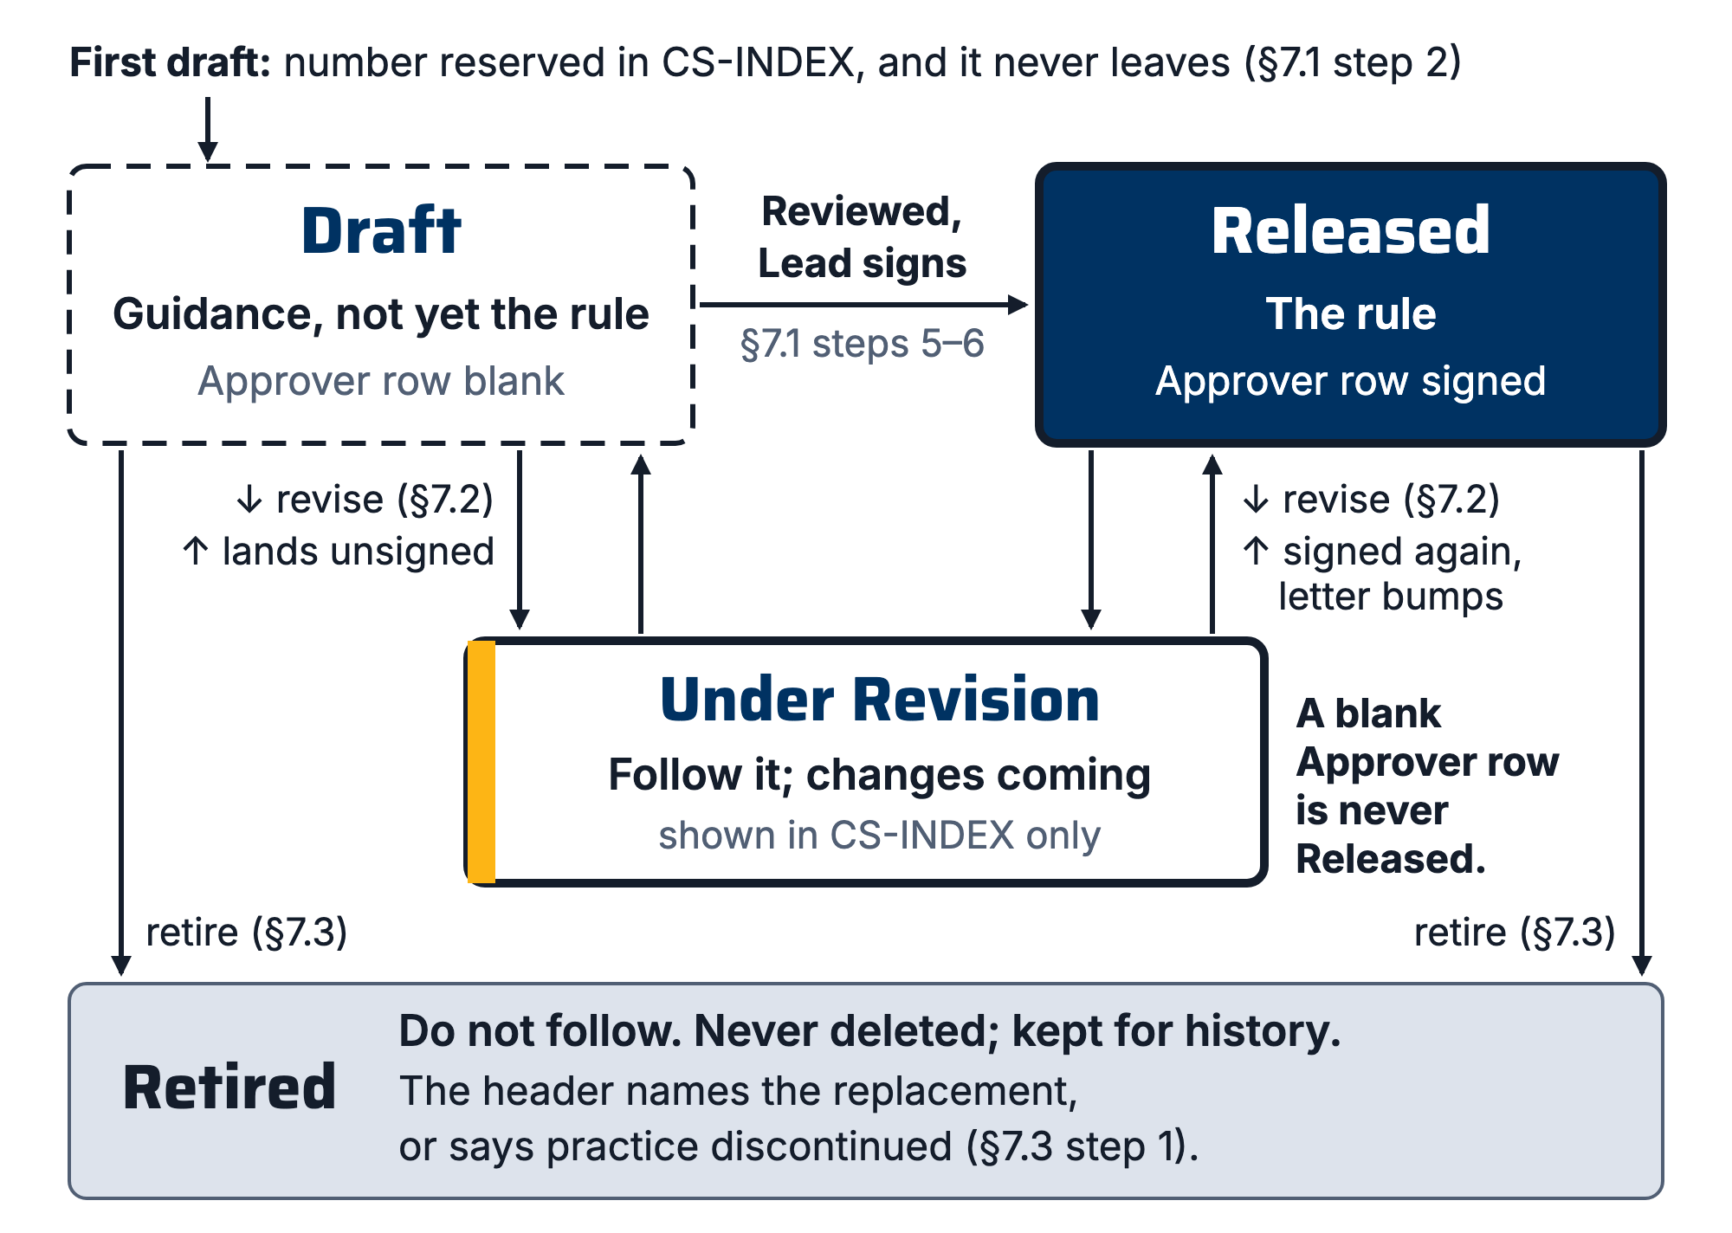
Figure 1. The status lifecycle. A document enters CS-INDEX at first draft and never leaves; Retired is an end state, deletion is not one.

5. Equipment & Materials
None; this is a process standard. Each standard's source is its markdown file in 02 CS Standards/src/ in the team repo, with figures as SVG in src/figures/. Everything else is built from that source: a .docx in 02 CS Standards/, and a PDF the app serves at docs/standards/CS-0xx.pdf. The Documents tab does not list the standards; Paul's source chips open the PDF. The August 2026 Google Docs copies are retired and frozen (02 CS Standards/GOOGLE-DOCS.md). The master list is CS-INDEX.

6. Safety
No physical hazards; this is a process standard. (The section exists because every CS doc must carry one: CS-Template §6.)

7. Procedure

7.1 Creating a new standard
- Check CS-INDEX for an existing standard covering the topic; extend rather than duplicate.
- Copy CS-Template; take the next free CS number from CS-INDEX and add a row there with Status = Draft immediately (this reserves the number).
- Write the draft. Every quantitative claim gets a source: a TDS/SDS in 03 Datasheets/ (add it and its INDEX row if missing), a test report, or a recorded team measurement (work order ID). "We've always done it this way" is not a source; if that's all there is, say so explicitly in the text.
- Draw a figure where one carries the geometry better than prose: keep-out zones, stack-ups, plumbing, anything dimensioned. The SVG in 02 CS Standards/src/figures/ is the source. node tools/render_figures.mjs renders it to PNG in Saira (titles) and Inter (labels), and the markdown references the PNG with the caption as its alt text; the build numbers the captions. Every distinction in a figure must survive a grayscale print (line weight, hatching, solid against hollow); Berkeley blue and gold are enhancement only, same rule as the shop travelers. No text smaller than about 9 pt at 6.5 in print width. A changed figure gets a new filename, because the app's host caches PNGs for a year. Details are in STYLE.md §5.
- Get the draft reviewed by someone who did not write it. An agent review, recorded as "simon (reviewer agent)" with its date, satisfies this step for a process standard. A shop procedure also needs a member who did not write it to walk it, physically where the steps are physical, before the lead signs; record their name in the Reviewer row beside the agent's. The Reviewer row names the review of the current revision, with its date.
- The Composites Lead approves in writing: a Slack message or a comment on the PDF that names the document and revision is enough. Whoever maintains the repo records it: the lead's name and the date in the Approver row, Status → Released in the header and in CS-INDEX, and a link to the approval in the commit message. Then rebuild and deploy as §7.2 steps 6 and 7 say.

7.2 Revising a standard
- Anyone may propose a revision. The trigger that matters most is an incident: if a part or mold is lost to a process failure, the relevant standard gets reviewed within two weeks while memory is fresh, and either revised or explicitly re-affirmed in its changelog.
- Set Status → Under Revision in CS-INDEX so users know changes are coming. Write it in CS-INDEX only, while the draft lives outside src/; the header of the current src/ copy keeps its status until the revision lands. check_traceability.py --strict may report the INDEX and header pair while a revision is in flight; that warning is expected until the revision lands.
- Make the change, add a revision-history row (what changed and why, one line each), bump the revision letter.
- Same review + approval as 7.1.
- In the same change as step 3, update everything that depends on this standard: re-check each quick reference whose Parent is this standard and move its Checked against; update each card in 04 Printables/printables.html that names the revision; and if a section number moved, update every CS-0xx §n.n reference in other standards and in the app's code. python3 tools/check_traceability.py lists the quick references and references that no longer agree.
- Rebuild the outputs from the repo root: node tools/render_figures.mjs (only if an SVG changed), tools/.venv/bin/python tools/build_docx.py --all, python3 tools/gen_docs_manifest.py, node tools/build_ai_corpus.mjs, then python3 tools/check_traceability.py --strict. Commit the source and every rebuilt file together.
- Deploy both. A revision reaches members only after the app's hosting deploy (firebase deploy --only hosting from 06 Composites App/, which carries the in-app PDF), and reaches Paul only after the functions deploy (firebase deploy --only functions, which carries the corpus Paul searches; it is deployed separately from hosting). The step 6 commit message names both deploys still to run; run them after the push. Announce a released revision in the weekly summary message only after both deploys.
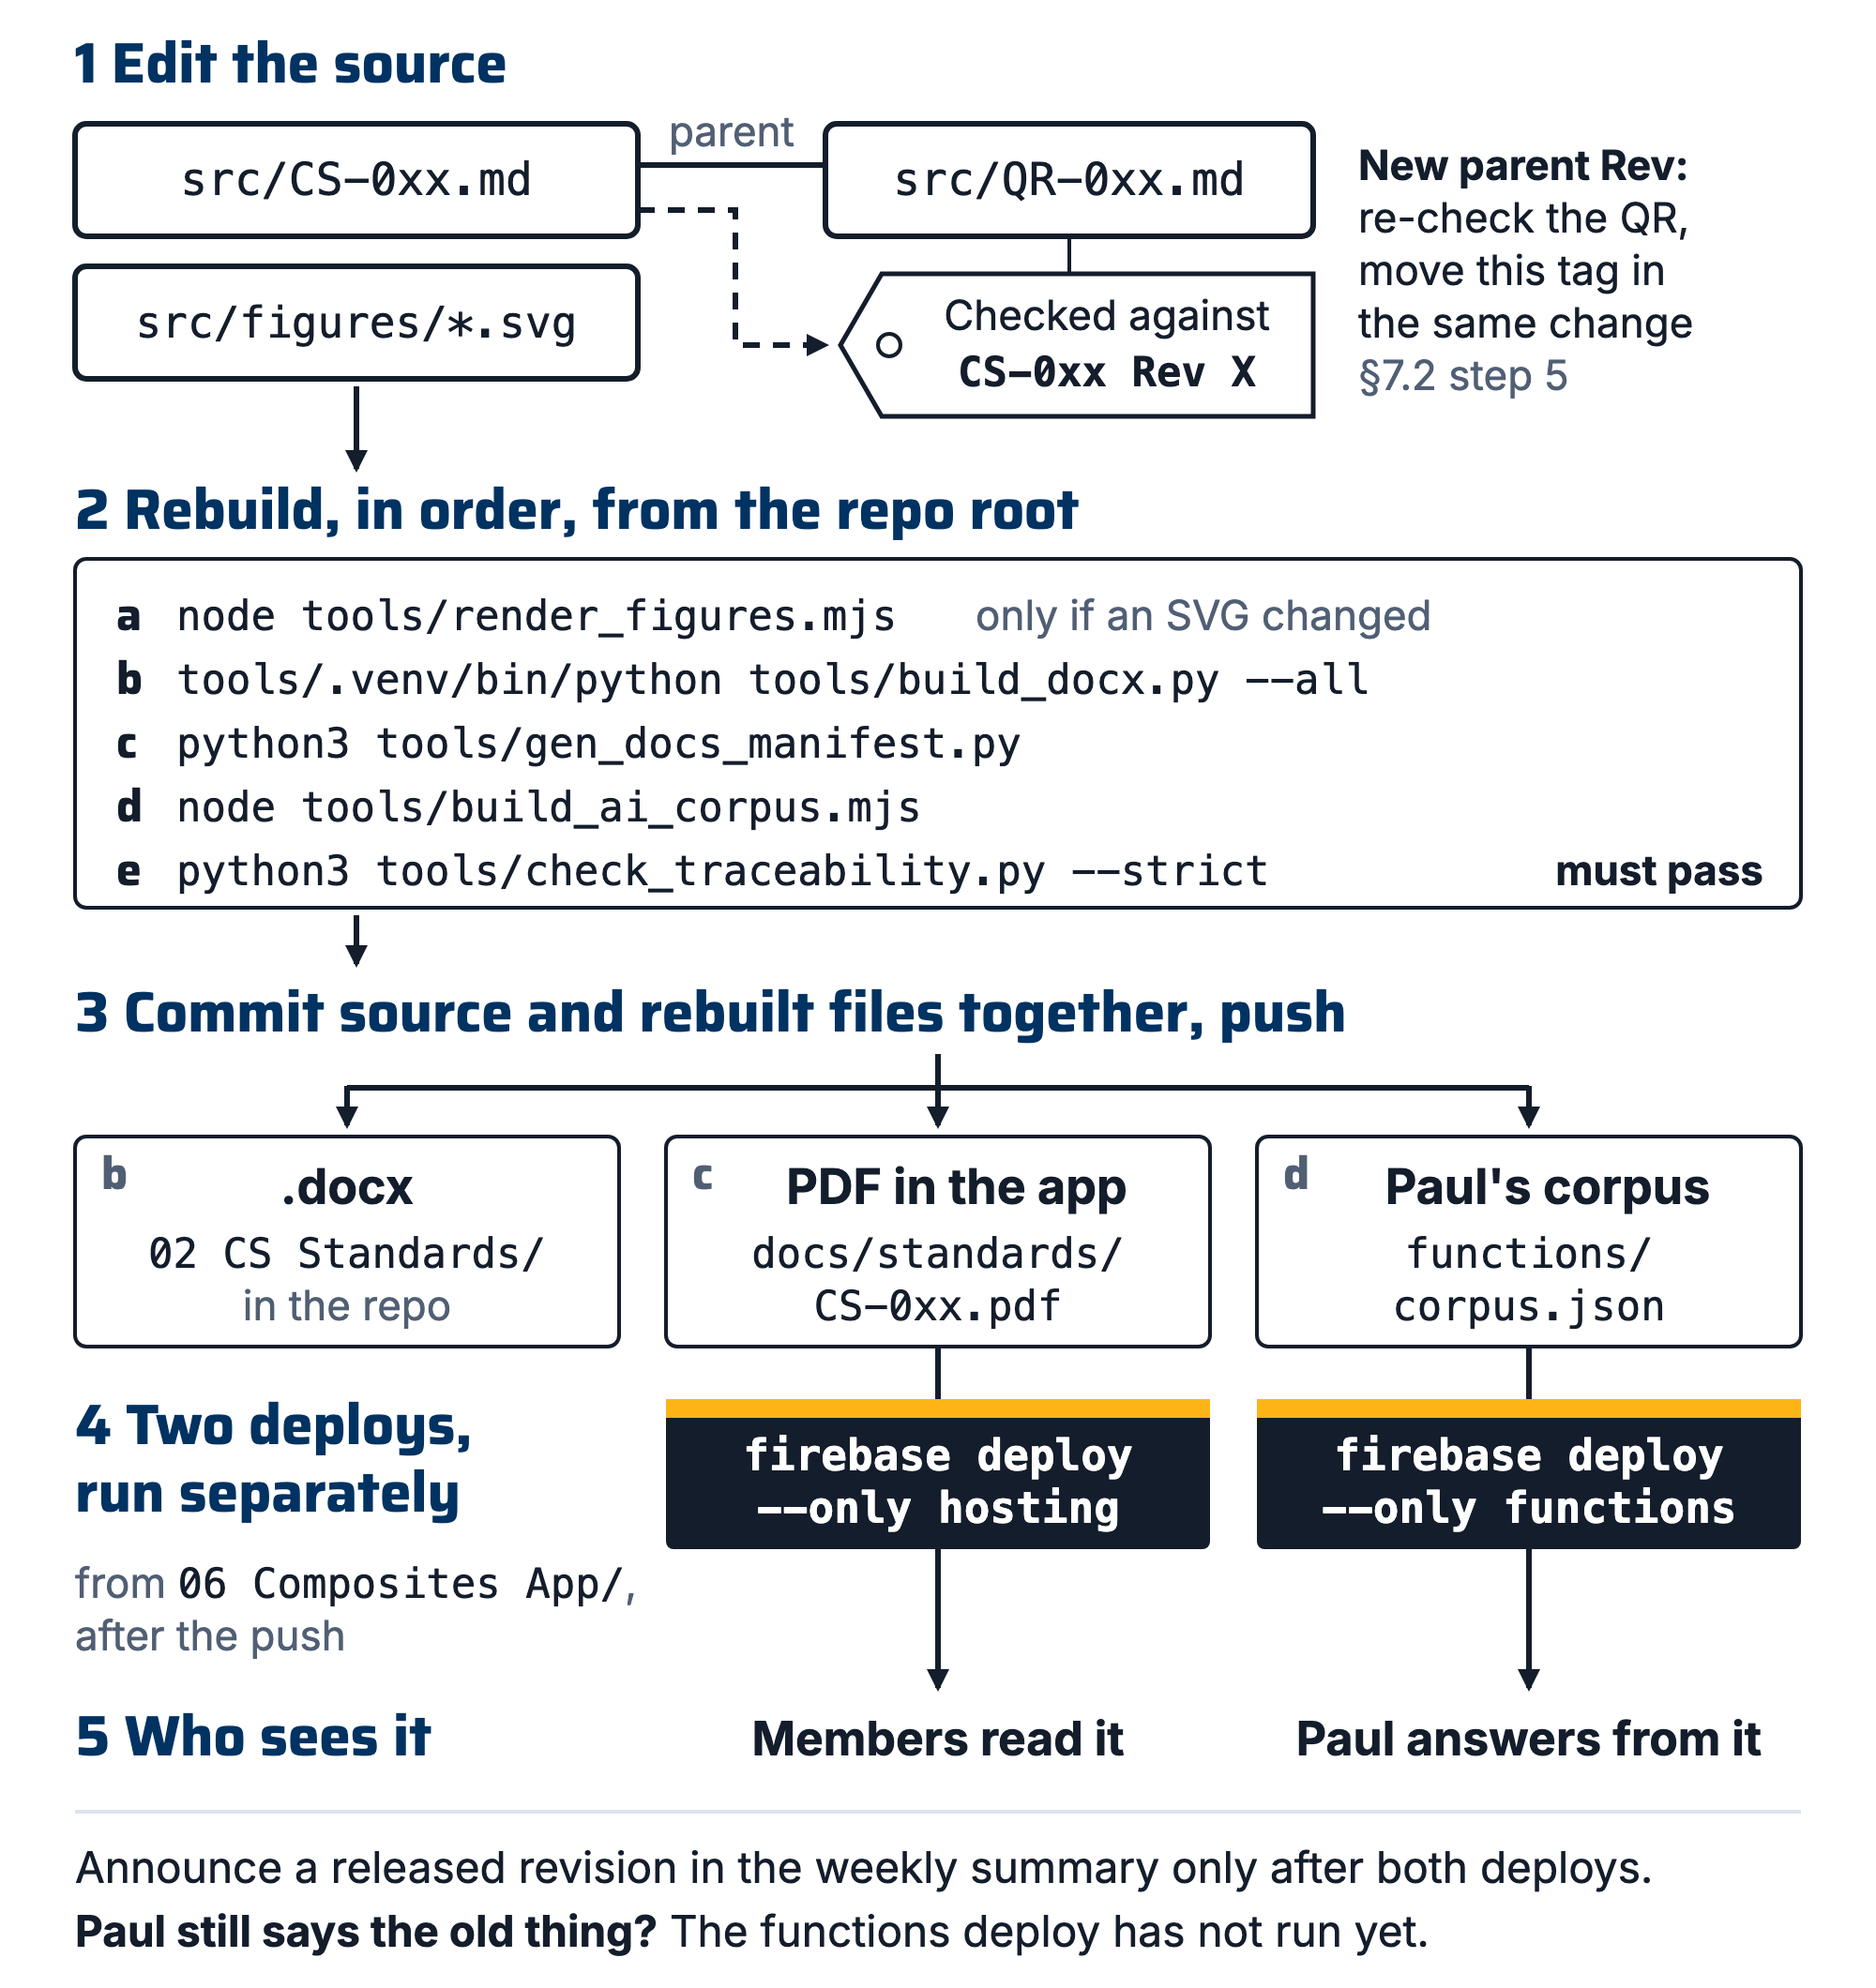
Figure 2. From source to shop: an edited standard's markdown and SVG figures go through the rebuild to the .docx, the in-app PDF and Paul's corpus; the hosting deploy brings the PDF to members and the functions deploy brings the corpus to Paul; a quick reference hangs off its parent and is re-checked against the parent's new revision.

7.3 Retiring a standard
- Set Status → Retired in the doc header and CS-INDEX; state the replacement (a CS number, or "practice discontinued").
- Never delete the file. Retired docs are the team's institutional memory (the Duratec story is worth more retired than deleted).

7.4 Annual handoff review
- Each summer, the incoming lead skims every Released or Draft standard with the outgoing lead (budget ~2 hours total) and marks each: still right / needs revision / retire.
- Findings go into CS-INDEX under Handoff reviews; revisions get scheduled, not just wished for.
Keep CS-INDEX current at the moment of change, not later: it is the one place that lists every document, its revision and its status.

7.5 Writing or updating a quick reference
- Take the next free QR number from CS-INDEX and add its row to the Quick references table there. This reserves the number, as §7.1 step 2 does for a standard.
- Copy template/QR-Template.md. The H1 is # QR-0xx Title; the header carries Doc ID, Title, Parent and Checked against, or Covers for a quick reference about using the app.
- Copy every number from the parent or a datasheet, with its citation. A quick reference never introduces a number.
- Write each ## section to stand alone: 300 to 2,400 characters, the answer in its first 240 characters, the heading in the words people ask with, and an Also called: line (STYLE.md §6).
- Run python3 tools/check_traceability.py --strict. It fails a quick reference whose Parent does not resolve to a heading or whose parent has moved past its Checked against revision.
- Rebuild and deploy as §7.2 steps 6 and 7 say. A quick reference reaches Paul only after the functions deploy.
- When the parent is revised, re-check the quick reference and move its Checked against in the same change (§7.2 step 5).

8. Quality checks / acceptance criteria
Check | Target | Method | Record where
Every released CS doc has ID, revision, approver, changelog; header, last history row and CS-INDEX agree | 100% | python3 tools/check_traceability.py --strict | CS-INDEX
Quantitative claims cite a source | Every number traceable | Reviewer walk-through (7.1 step 5) | Review comment in doc
Post-incident review | Within 2 weeks of losing a part/mold | Lead checks at the weekly meeting | Changelog row
Annual handoff review done | Before fall recruiting | Incoming lead | CS-INDEX, Handoff reviews
Every CS-0xx §n.n reference resolves; every figure PNG is current with its SVG | 100% | python3 tools/check_traceability.py --strict | Commit
Quick references checked against the parent's current revision | 100% | python3 tools/check_traceability.py --strict | QR header (Checked against)
Built copies match the source | An unchanged standard rebuilds byte-identical | Rebuild (§7.2 step 6), then git status | Commit

9. Records
CS-INDEX is the record of what exists and its status. Each standard's revision history says what changed and why. The repo's commit history of 02 CS Standards/src/ is the record of every edit, including path fixes that took no letter (src/rev-exemptions.txt). Work orders (CS-013) record per-part execution; this standard records how the documents themselves are kept honest.

Appendix: why this exists
SN5's two documentation tiers were formal deliverables (author + date, no versioning) and stub templates (often empty). Both rotted silently: the Mold Sealer Alternatives study (Oct 2025) recommended S120/water-based sealers, was overtaken by the XCR decision (Feb–Apr 2026), and nothing marked it superseded. A new member reading the Drive in July 2026 could not tell which document described current practice. Status fields and CS-INDEX exist to make "which doc is true" a lookup instead of an archaeology project.

